17th December 2024

Assalaamu alaikum warahmatullahe wabarakatuh

Dear respected parents/carers,

Re: Winter holiday revision classes

I pray that you are in the best of Health and Imaan.

We will be continuing with the holiday revision and booster sessions for all year 11 students. These will be intensive sessions that will help students review key concepts, bridge gaps in learning and prepare them for the upcoming GCSE exams.

Attendance is compulsory as it is vital that we support your daughter in achieving her target grade and improve her chances of admissions to further education.

The sessions will take place on:

Subject | Date | Time
History | Monday 23/12/2024 | 10 am to 2 pm
History | Tuesday 24/12/2024 | 10 am to 2 pm
Art | Thursday 26/12/2024 | 10 am to 2 pm
Physics | Friday 27/12/2024 | 10 am to 2 pm
Chemistry/Biology | Monday 30/12/2024 | 10 am to 2 pm
Biology | Tuesday 31/12/2024 | 10 am to 2 pm

If you have any further questions or difficulties in attending, please contact the school to reach an agreement with the Headteacher.

We rely on your support and cooperation in helping your daughter reach her full potential.

Kind regards,
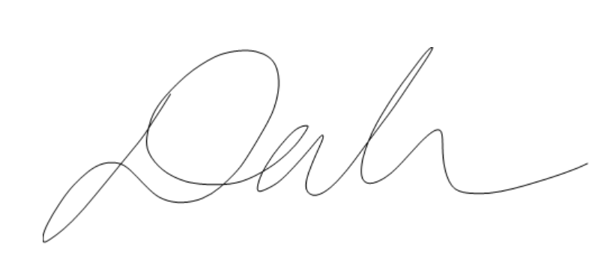
Ms Jihar

Headteacher

